**Research and Educational Micro/Nano Technology Center (MNTC)**

**Research Staff of the Micro/Nano Technology Center:**

* Prof. Michael Manevich, Head of Micro/Nano Technology Center;
* Dr. Miri Gelbaor Kirzhner, Researcher;
* Dr. Ygal Eisenberg, Researcher;
* Dr. Matvey Klebanov, Researcher;
* Joseph Varshal, M.Sc., Researcher.

**Prof. Michael Manevich**

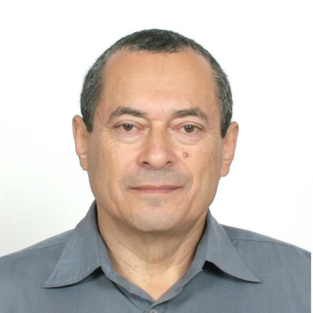

**Prof. Michael Manevich** is a Head of the Micro/Nano Technology Center at the Lev Academic Center. His Main Research Interests areNano science; Materials science; Micro/Nano technology; Dynamic micro-optics; Active UV, Vis, IR electro-optical materials (liquid crystals and dielectric elastomers), technologies, micro/nano and macroscopic devices and components and their applications; Photoinduced and surface effects in organic (photopolymers) and inorganic materials (photosensitive chalcogenides); 3D Micro/Nano characterization based on the micro-interferometry and optical microscopy; Renewable energy; Materials, technologies and tools for advanced wafer level packaging.

Prof. M. Manevich was a Principal Investigator of many research and development multidisciplinary projects supported by the NATO, Peace and Security Program; the Israel Innovation Authority (Magnet Program, ALTIA Consortium); the Ministry of Science, State of Israel; the Ministry of Industry and Trade, State of Israel (Magneton Program, Joint Project with Orbotech Ltd); the Ministry of Economy and Industry, State of Israel; the Ministry of Infrastructures, Energy and Water Resources, State of Israel; the Ministry of Environmental Protection, State of Israel and other research funds. He has extensive experience in implementation of joint multidisciplinary projects with Israeli and American academic teams and industrial companies.

His current research involves micro/nanotechnology; active micro-electro-optics; novel liquid crystal materials and technologies; development, characterization and application of innovative active micro/nano and macroscopic electro-optical devices based on liquid crystals and dielectric elastomers; technologies, materials and tools for advanced wafer level packaging; new organic and inorganic photosensitive materials; 3D nano-structuring and renewable energy. Presently he is a Principal Investigator of two projects, related to research and development of novel materials, design and technology for Active Micro/Nano-Electro-Optical Components, funded by the Ministry of Environmental Protection, State of Israel and the Lev Academic Center R&D Authority, State of Israel.

Prof. M. Manevich is the author of over 140 publications, 12 patents, he has won over 80 R&D grants in the fields of micro/nanotechnology, advanced materials and active micro/nano devices.

Prof. M. Manevich is one of the globally recognized experts in the research, development and applications of micro/nanotechnology and liquid crystal materials. He is the co-inventor of several unique materials, innovative technologies and micro/nano devices.

**The** **Main Achievements are Related to the Following Research and Development:**

* Creation of the Micro/Nano Technology Center;
* Research and development of unique materials and technology for innovative dry vacuum nanolithography (with co-authors);
* Research and development of unique materials and technology for innovative laser induced thermal nanolithography (with co-authors);
* Research and development of innovative ultrafast active electro-optical materials (with co-authors);
* Research and development of innovative ultrafast active micro-electro-optical devices and components (with co-authors);
* Development of the new micro-optical devices for the UV, Vis and IR ranges: micro-lens arrays, micro-mirror arrays, micro-prism arrays and Fresnel micro-lenses (with co-authors).

**Active and Recently Completed Projects (2019 – 2021) of Prof. Michael Manevich**

* Ultra-fast adaptive optical elements based on stressed liquid crystals, International Research Project funded by NATO Emerging Security Challenges Division, 2015 – 2019, Principal Investigators: Prof. J. West, Kent State University, Kent, OH, USA; Prof. M. Manevich, Lev Academic Center, Jerusalem, Israel; Prof. V. Nazarenko, Institute of Physics, Ukrainian Academy of Sciences, Kyiv, Ukraine.
* Development of microstructures and technologies for novel ultra-fast dynamic micro-optical components, funded by the Israel Innovation Authority, Magnet Program, ALTIA Consortium, Joint Project with Orbotech, Ltd. (Dr. Zvi Kotler), 2016-2019, Principal Investigator:

Prof. M. Manevich, Lev Academic Center, Jerusalem.

* Research and development of fast switching smart window based on liquid crystal material, funded by the Ministry of Environmental Protection, State of Israel, 2017-2021, Principal Investigator: Prof. M. Manevich, Lev Academic Center, Jerusalem.
* Development of microstructure based on active electro-optical material, R&D Grant, funded by the Lev Academic Center R&D Authority, Israel, 2018-2019.
* Developing concept and structure of measuring system for testing switching time of adaptive electro-optical materials, R&D Grant, Phase #1, funded by the Lev Academic Center R&D Authority, Israel, 2019.
* Developing concept and structure of measuring system for testing switching time of adaptive electro-optical materials, R&D Grant, Phase #2, funded by the Lev Academic Center R&D Authority, Israel, 2019-2020.
* Initial assembly and test of measuring micro-electro-optical system for testing switching time of adaptive electro-optical materials, R&D Grant, funded by the Lev Academic Center R&D Authority, Israel, 2020.
* Development of innovative maskless microlithography based on micro-lens arrays, R&D Grant, Phase #1, funded by the Lev Academic Center R&D Authority, Israel, 2020-2021.

**International and National Collaborations** **with Academia and Industry:**

* Prof. J. West, Kent State University, Kent, OH, USA. Joint research area: novel fast liquid crystal technology.
* Prof. A. Glushchenko, University of Colorado, Colorado Springs, CO, USA. Joint research area: new application of liquid crystal technology.
* Prof. P. Shibayev, Fordham University, New York, NY, USA. Joint research area: advanced composite materials based on chalcogenides and liquid crystals.
* Prof. V. Nazarenko, Institute of Physics, Ukrainian Academy of Sciences, Kyiv, Ukraine. Joint research area: innovative active micro-electro-optical devices.
* Prof. V. Gorobets, TEKNCITy Inc, Redmond, WA, USA. Joint R&D area: ultra-resolution nanotechnology.
* Dr. Zvi Kotler, Orbotech Ltd. Joint R&D area: development of microstructures and technologies for novel ultrafast dynamic micro-optical components.

**Dr. Miri Gelbaor Kirzhner**

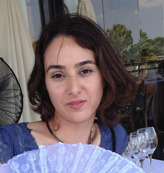

**Dr. Miri Gelbaor Kirzhner** received her B.Sc. in physics, and M.Sc. (summa cum laude) and Ph.D. in Electro-Optics Engineering from Ben-Gurion University of the Negev (Beer-Sheva, Israel). Her M.Sc. and Ph.D. studies dealt with liquid crystal devices integrated with nano-dimensional chalcogenide films. Dr. Miri Gelbaor Kirzhner, as an experimental researcher, has experience with Nematic and Ferroelectric liquid crystal devices, stressed liquid crystals, thin films, chalcogenide glasses, photoalignment of liquid crystals, integrated optical devices, nano-photonics optically addressed spatial light modulators, beam shapers and smart windows. Her experience also includes design, fabrication and characterization of electro-optical devices, and working in a clean room class 100. She has about 20 publications and patents. and was awarded the Negev scholarship for excellent doctoral students. Since 2016 Miri serves as a researcher at the Micro/Nano Technology Center of the Lev Academic Center. She is actively involved in several R&D Projects funded by the Israel Innovative Authority, the Ministry of Environmental Protection and the LAC R&D Authority.

**Dr. Ygal Eisenberg**

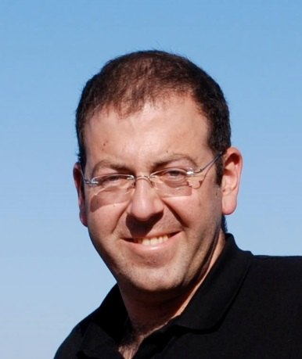

**Dr. Ygal Eisenberg** received his B.Tech. in electro-optics (he was awarded the First Prize of the International Solar Energy Society for the first-degree final project on June, 2007) and MBA from the Jerusalem College of Technology and holds his M.Sc. in electro-optics and PhD in Electro-Optics Engineering from the Ben-Gurion University of the Negev (Beer Sheva, Israel).

Dr. Ygal Eisenberg, as an experimental researcher, has extensive and successful experience in the design, research and development of new technologies of diffractive optical elements, micro-optics, photovoltaic devices and microlithography. His areas of interest include advanced microtechnology systems, 3D characterization of microstructures using optical microscopy, white light micro-interferometry and multiwavelength confocal scanning microscopy. Ygal has experience in laboratory and industrial cleanrooms using state-of-the-art equipment such as sputtering and PECVD installations for nanoscale layers and thin film deposition, microlithography equipment and advanced 3D nano/micro characterization and measurement systems. For about 10 years, he has been responsible for developing new industrial processes for the production of advanced silicon solar cells using nanotechnology, adapting laboratory processes for mass production, synchronizing production between different manufacturing companies, mainly abroad, as well as identification and analysis of failures and providing real-time solutions. Dr. Ygal Eisenberg has publications in the microtechnology, micro-optic and photovoltaic areas. Currently Dr. Eisenberg serves as a Researcher at the Micro/Nano Technology Center.

**Dr. Matvey Klebanov**

**Dr. Matvey Klebanov** received his M.Sc. in Experimental Physics and his PhD in Physics and Mathematics (Title of thesis: "Study of Laser Damages and Emission Properties of Surfaces of Optical Materials"), both from the Yekaterinburg State Polytechnic University, Russia.

Employment History in Israel:

01.03.1992 – 30.04.2013: Senior Research Fellow, Laboratory of Amorphous Semiconductors, Department of Physics, Ben‑Gurion University of the Negev, Beer‑Sheva, Israel.

01.05.2013 – 30.09.2020: Head of the Laboratory of Amorphous Semiconductors, Department of Physics, Ben‑Gurion University of the Negev, Beer‑Sheva, Israel.

01.01.2021 – Present: Researcher at the Micro/Nano Technology Center of the Lev Academic Center, Jerusalem.

Dr. Matvey Klebanov has an extensive experience in micro-optics; diffractive optics and microelectronics technology; modern vacuum technology and equipment; vacuum thin and ultra-thin metal, semiconductor and dielectric film coatings; development and fabrication of antireflective and protective coatings; precise optical measurements; chemical and thermal processes; micro/nanotechnology; micromechanics.

Dr. Matvey Klebanov is one of the world’s recognized experts in science, development and applications of the Chalcogenide Materials.

Among his most known achievements are:

* Study of photoinduced phenomena in glassy semiconductors and their applications in electro-optics and microelectronics (together with co-authors).
* Study of Photoinduced Anisotropic Phenomena in Chalcogenide Glassy Thin Films (together with Prof. V. Lubin).
* Liquid Crystal Photoalignment based on Photoinduced Anisotropy in Chalcogenide Glassy Thin Films (together with co-authors).
* Developing two types of the novel Chalcogenide Materials possessing the unique properties: As-Se-S and Ge-Pb-S compositions (together with Prof. V. Lubin).
* Development of the new Micro-optical Devices for the Infrared range: Micro-lens Arrays, Micro-mirror Arrays, Micro-prism Arrays and Fresnel Micro-lenses (together with co-authors).

Dr. Matvey Klebanovprovides an extended collaboration with the leading international research centers in the USA (Prof. A. Kumar), UK (Prof. N. Collings, Prof. V. Tikhomirov), Belgium (Prof. G. Adriaenssens), Japan (Prof. K. Tanaka, Prof. A. V. Kolobov), Bulgaria (Prof. M. Mitkova), Czech Republic (Prof. N. Froumin), Romania (Prof. M. Popesku), etc.

Dr. Matvey Klebanov has more than 150 publications and patents on advanced optical devices, measurements and novel micro/nano/optical materials, including about 100 peer reviewed scientific articles on the Chalcogenide Materials, Technologies and Applications.

**Joseph Varshal, M.Sc.**



**Joseph Varshal** received his M.Sc. from the Novosibirsk Technical University, Russia in Micromechanics and Microelectronics. Joseph has extensive experience in micromechanics, micro/nanotechnology, including passive and active micro-optics, diffractive optics and microelectronics technology, including modern photo-lithographic techniques, chemical and thermal processes; liquid crystal application in active micro-optics technology; development and fabrication of antireflective and protective coatings; thin film vacuum evaporation of metal, semiconductor and dielectric materials; precision wet and dry etch processes of metal, semiconductor and dielectric

thin films and substrate materials. Joseph participated in many joint R&D and industrial projects with Israeli and American Academic Teams and Hi-Tech Industrial Companies. He has numerous publications, 6 patents and 27 published projects in the field of microtechnology. Since 2004 Joseph serves as a researcher at the Micro/Nanotechnology of the Lev Academic Center. He was actively involved in many R&D Projects funded by the NATO Emerging Security Challenges Division, the Israel Innovative Authority, the Ministry of Science and Technology State of Israel, the Ministry of Economy and Industry State of Israel, the Ministry of Energy and Water Resources State of Israel, the Ministry of Environmental Protection State of Israel and the LAC R&D Authority.

**List of 29 R&D Active and Completed Projects of the MNTC Over the Past Twelve Years**

1. Ultra-fast adaptive optical elements based on stressed liquid crystals, Research Project, NATO Emerging Security Challenges Division, 2015 – 2019, Project Co-Directors: Prof. John L. West, Kent State University, OH, USA; Prof. Michael Manevich, Lev Academic Center, Jerusalem, Israel;

V. Nazarenko, Institute of Physics, Ukrainian Academy of Sciences, Kyiv, Ukraine.

2. Development of Micro-structures and Technologies for Novel Ultrafast Dynamic Micro-optical Components, the Israel Innovation Authority, Magnet Program, ALTIA Consortium, Joint Project with Dr. Zvi Kotler (Orbotech ltd), 2016 – 2019, Principal Investigator: Prof. Michael Manevich.

3. Liquid Crystal Devices for Laser Micromachining – LC4LM, Joint R&D Project with Orbotech Ltd funded by the Israeli Ministry of Industry and Trade, Magneton Program,2011 - 2013.

4. Proof of Concept for High Efficiency Solar Energy to Electricity Nanoconverter, Research Project, the Ministry of Infrastructures, Energy and Water Resources, State of Israel, 2015 – 2016.

5. Investigation of photoinduced orientation of liquid crystals by chalcogenide surface and application for adaptive micro-lens array technology, the Ministry of Science and Technology, State of Israel, Research Project, 2009-2010.

6. Development of advanced photosensitive materials for alignment of liquid crystals and their application in adaptive micro-lens array technology, the Ministry of Science and Technology, State of Israel, Research Project, 2006-2009.

7. Research and development of fast switching smart window based on liquid crystal material, funded by the Ministry of Environmental Protection, State of Israel, 2017-2021.

8. Development of Innovative Maskless Microlithography based on Micro-lens Arrays, R&D Grant, Phase #1, funded by the Lev Academic Center R&D Authority, Israel, 2020 - 2021.

9. Initial Assembly and Test of Measuring Micro-electro-optical System for Testing Switching Time of Adaptive Electro-optical Materials, R&D Grant, Phase #3, funded by the Lev Academic Center R&D Authority, Israel, 2020.

10. Developing Concept and Structure of Measuring System for Testing Switching Time of Adaptive Electro-optical Materials, R&D Grant, Phase #2, funded by the Lev Academic Center R&D Authority, Israel, 2019 - 2020.

11. Developing Concept and Structure of Measuring System for Testing Switching Time of Adaptive Electro-optical Materials, R&D Grant, Phase #1, funded by the Lev Academic Center R&D Authority, Israel, 2019.

12. Development of Microstructure for Smart Window Model Based on Active Electro-optical Material, R&D Grant, funded by the Lev Academic Center R&D Authority, Israel, 2018 - 2019.

13. Tuning the assembled micro-electro-optical system for direct measuring the Liquid Crystal (LC) cell transmittance, during alignment of LC molecules, using a micromechanical shear; development of the measurement procedure, R&D Grant, funded by the Lev Academic Center R&D Authority, Israel, 2018.

14. Creation of the micro-electro-optical system for direct measuring the Liquid Crystal (LC) cell transmittance, during alignment of LC molecules, using a micromechanical shear, R&D Grant, funded by the Lev Academic Center R&D Authority, Israel, 2017 - 2018.

15. Concept and design development of the micro-electro-optical system for direct measuring the Liquid Crystal (LC) cell transmittance, during alignment of LC molecules, using a micromechanical shear, R&D Grant, funded by the Lev Academic Center R&D Authority, Israel, 2017.

16. Development of Basic Design and Manufacturing Technology for Millimeter-sized Lens Arrays Operated in the IR Range, R&D Grant, funded by the Lev Academic Center R&D Authority, Israel, 2016 - 2017.

17. Development of Infrared Laser Beam Shaper Based on All-Silicon Micro-structure, JCT R&D Grant, Israel, 2016.

18. Development of Micro-structure and Novel Technology for Infrared Laser Beam Shaper, JCT R&D Grant, Israel, 2015 – 2016.

19. Optimization of Chalcogenide Material Optical Properties, Development of Optical Micro-Waveguide Array Design and Fabrication of the Experimental Sample, JCT R&D Grant, Israel, 2014 – 2015.

20. Development of Design and Technology for Controllable Macroscopic Lenses based on Elastomer Materials and Variable Nitrogen Pressure, JCT R&D Grant, Israel, 2013 – 2014.

21. Feasibility Study of Adaptive Fluidic Optical Component Formation Using Electrowetting, JCT R&D Grant, Israel, 2013 – 2014.

22. Development and fabrication of new unique fast-switching adaptive micro-lens arrays based on stressed liquid crystals, JCT R&D Grant, Israel, 2013.

23. Development of Construction and Technology for Electrically Tunable Lenses based on Dielectric Elastomer Films, JCT R&D Grant, Israel, 2012 – 2013.

24. Feasibility Study of Adaptive Fluidic Optical Component Formation, JCT R&D Grant, Israel, 2012 – 2013.

25. Investigation of New Phenomena in Dielectric Elastomer Films; Feasibility Study of Adaptive Micro-optical Component Formation, JCT R&D Grant, Israel, 2011 – 2012.

26. Development of Technology for Creation of CellCam Video Camera for IR Diagnosis, Detection, Monitoring and Laser Based Treatment of Cancer Cells, JCT R&D Grant, Israel, 2011 – 2012.

27. Investigation of new phenomena in super-thin amorphous chalcogenide films; feasibility study of micro-tube formation, JCT R&D Grant, Israel, 2010 – 2011.

28. Development of design and fabrication technology for reliable adaptive spherical micro-mirror arrays based on chalcogenide and liquid crystal materials, JCT R&D Grant, Israel, 2009-2010.

29. Development of design and fabrication technology of active micro-lens arrays for the visible range based on a hole-patterned electrode structure and liquid crystal material, JCT R&D Grant, Israel, 2007-2009.

**Publications and Patents.**

The scientists of the Micro/Nano Technology Center have more than 310 publications and 22 patents.

**Existing Infrastructure, Research Facilities and Clean Room Space:**

All ongoing projects are carried out in the Micro/Nano Technology Center, consisting of the seven jointly acting laboratories:

* Adaptive Micro/Electro/Optics Lab;
* Micro/Nano Structuring Lab;
* Liquid Crystal Lab;
* Micro/Nano Chemistry Lab;
* Micro/Nano Characterization Lab;
* Micromechanics Lab;
* Electronics Lab.

The center, is equipped with all the R&D facilities, necessary for the implementation of ongoing projects, including the clean room: class 100, used for micro and nano processing, and class 10,000, used for general technology processing. The list of existing modern equipment available at the Micro/Nano Technology Center consists of 43 items.

**Main Research Areas of the Micro/Nano Technology Center:**

* + Nano Science
  + Materials Science
  + Micro/Nano Technology
  + Active Micro/Electro/Optics
  + 3D Micro/Nano Characterization
  + Renewable Energy
  + Technologies, Materials and Tools for Advanced Wafer Level Packaging

**Basic Developed Passive and Active Nano, Micro and Macroscopic Electro-Optical and Electronic Components**

* + Ultrafast Dynamic Beam Shapers
  + Micro-lens Arrays
  + Micro-mirror Arrays
  + Fresnel Micro-lens Arrays
  + Micro-prism Arrays
  + Single Macroscopic Lenses and Macroscopic Lens Arrays
  + Optical Micro Waveguide Arrays
  + Micro-Optical Beam Splitters
  + Micro-Optical Beam Combiners

**Developed Technologies for Basic Passive and Active Nano, Micro and Macroscopic Electro-Optical and Electronic Components**

* Gray Scale Micro-Lithography Method
* Gap Micro-Lithography Method
* Modified Proximity Micro-Lithography Method
* Thermal Reflow Method
* Reactive-Ion Etching
* 3D Double-sided Alignment
* Micro Scale Vacuum Packaging
* Room Temperature Vacuum Sealing
* Casting Technology using Cold Embossing Mold

**Basic Materials for Passive UV, Visible and IR Nano, Micro and Macroscopic Electro-Optical and Electronic Components**

* Silicon (Si): Transmission range of 1.2 to 7.0 μm
* Gallium Arsenide (GaAs): Transmission range of 2 to 15 μm
* Germanium (Ge): Transmission range of 2 to 14 μm
* Fused Silica (SiO2), IR Grade: Transmission range of 0.25 to 3.5 μm
* BK7 Schott Glass: Transmission range of 0.35 to 2.0 μm
* Optical Polymer: Transmission ranges: of 0.35-2.0 μm; 3.7-5.0 μm
* As40Se60 : Transmission range of 0.9 – 14 µm
* Indium Tin Oxide: Transmission range of 350 – 700 nm

**Basic Materials for Active UV, Visible and IR Micro and Macroscopic Optical Components**

* Liquid Crystals
* Dielectric Elastomers
* Nano-colloids

**Our R&D Expertise in 3D Micro/Nano Technology, Active Electro-Optics and Measurements**

**Plano-Concave Micro-Mirror Array**

**Plano-Convex Micro-Lens Array**

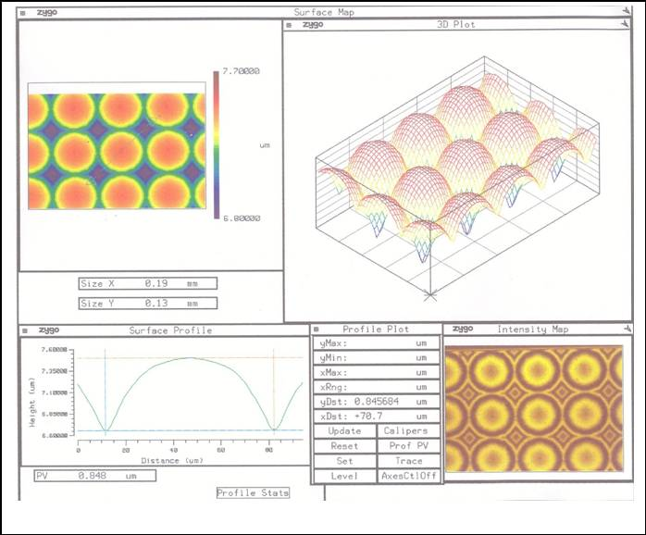

**a**

|  |  |
| --- | --- |
| **Main Parameters of Developed, Fabricated and Measured Plano-Convex Micro-Lens Array** | |
| Micro-Lens Diameter, µm | 49 |
| Micro-Lens Sag, µm | 0.85 |
| Focal Length, µm | 543 |
| Micro-Lens Array Pitch, µm | 50 × 50 |
| Micro-Lens Array Size, mm | 15 × 15 |
| Roughness, nm | 1.4 |

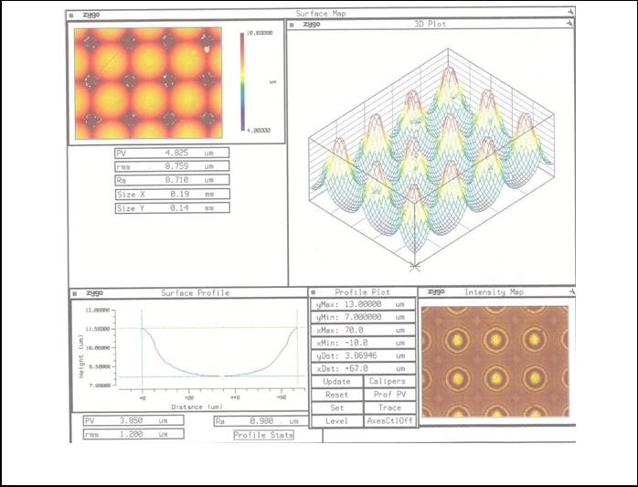

**b**

|  |  |
| --- | --- |
| **Main Parameters of Developed, Fabricated and Measured Plano-Concave Micro-Mirror Array** | |
| Micro-Mirror Diameter, µm | 47.5 |
| Depth, µm | 3.869 |
| Radius of Curvature, µm | 74.83 |
| Micro-Mirror Array Pitch, µm | 50 × 50 |
| Micro-Mirror Array Size, mm | 12 × 12 |
| Roughness, nm | 7.3 |

**Plano-Convex Macroscopic Lens**

**Plano-Convex Cylindrical Micro-Lens Array**

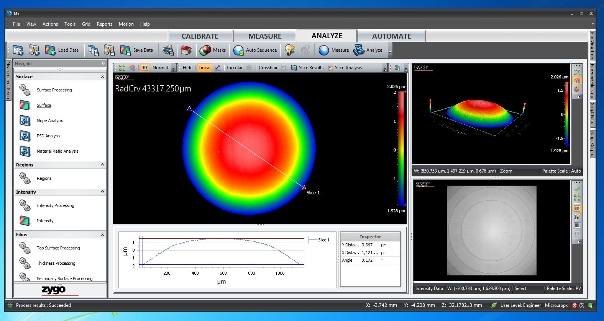

|  |  |
| --- | --- |
| **Main Parameters of Developed, Fabricated and Measured Plano-Convex Macroscopic Lens** | |
| Macroscopic Lens Diameter, µm | 1121 |
| Macroscopic Lens Sag, µm | 3.367 |
| Radius of Curvature, µm | 46654.5 |
| Focal Length, mm | 71.78 |
| Roughness, nm | 4.9 |

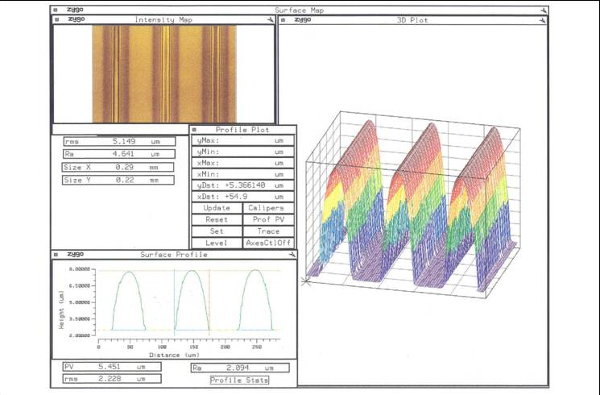

|  |  |
| --- | --- |
| **Main Parameters of Developed, Fabricated and Measured Cylindrical Micro-Lens Array** | |
| Micro-Lens Width, µm | 54.9 |
| Micro-Lens Sag, µm | 5.37 |
| Focal Length, µm | 112 |
| Micro-Lens Array Pitch, µm | 100 × 2000 |
| Micro-Lens Array Size, mm | 10 × 10 |
| Roughness, nm | 0.5 |

**c**

**Some Developed, Fabricated and Measured 3D Micro-structured Optical Components: a** - Plano-Convex Micro-Lens Array; **b -** Plano-Concave Micro-Mirror Array; c - Plano-Convex Cylindrical Micro-Lens Array;

**d** - Plano-Convex Macroscopic Lens.

**Developed, Fabricated and Measured Fresnel Micro-lens**

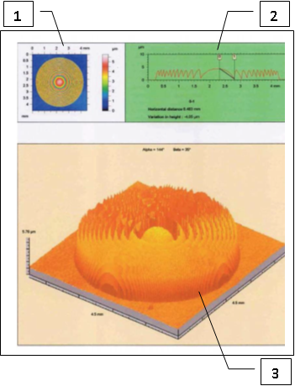

**1 - 2D Image of Fresnel Micro-lens - Top View;**

**2 – Micro-Profile Measurement; 3 - 3D Image of Fresnel Micro-lens.**

|  |  |
| --- | --- |
| **Main Parameters of Developed, Fabricated and Measured Fresnel Micro-lens** | |
| Fresnel Micro-Lens Diameter, mm | 4.0 |
| Fresnel Micro-Lens Sag, µm | 4.05 |
| Focal Length, mm | 58.2 |
| Roughness, nm | 3.7 |

**Developed, Fabricated and Measured Uniformly-Arranged Micro-Well Arrays with Very Wide Range of Micro-Well Volumes from Femtoliters to more than Nanoliters Based on Bottom-Up High-Resolution Technology**

**Main Parameters of Uniformly-Arranged Micro-Well Array:**

1. Micro-Well Diameter ⁓ 1.4 µm.

2. Micro-Well Depth ⁓ 400 nm.

3. Pitch of Micro-Wells in Array - 3.0 µm.

4. Density of Micro-Well Array ≈ 1.109 · 105 mm-2

5. Volume of the Micro-Well in Array ⁓ 0.6 µm3 = 0.6 fl (femtoliter).

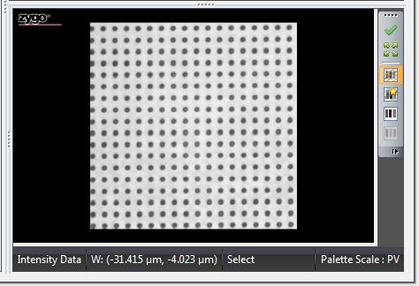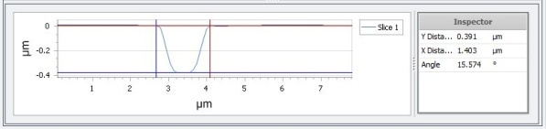

**Developed, Fabricated and Measured Microfluidic Channels**

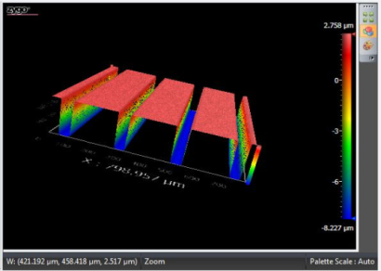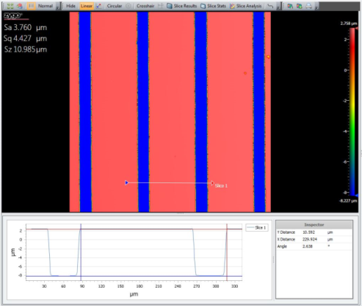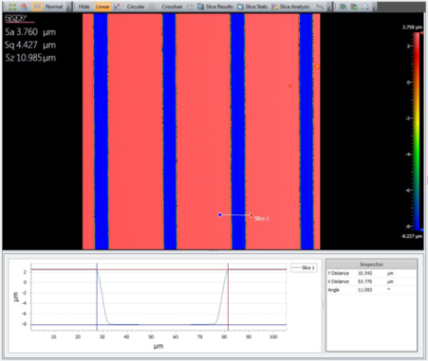

|  |  |
| --- | --- |
| **Main Parameters of Developed, Fabricated**  **and Measured Microfluidic Channels** | |
| Microfluidic Channel Width, µm | 53.8 |
| Microfluidic Channel Depth, µm | 10.54 |
| Microfluidic Channel Pitch, µm | 229.92 |
| Microfluidic Channel Length, mm | 20 |
| Microfluidic Channel Roughness, nm | ˂ 0.5 |

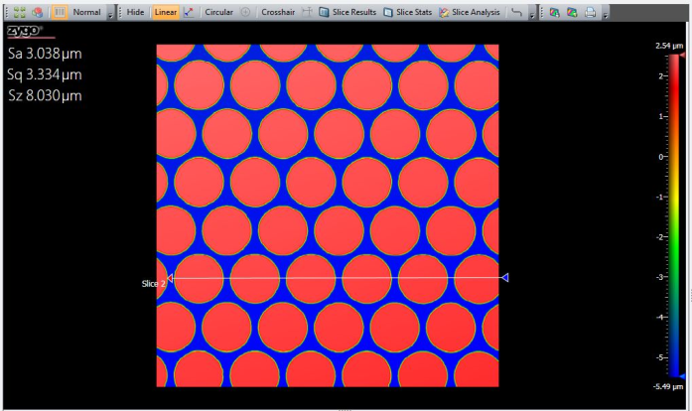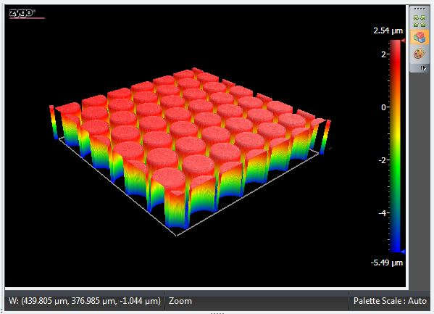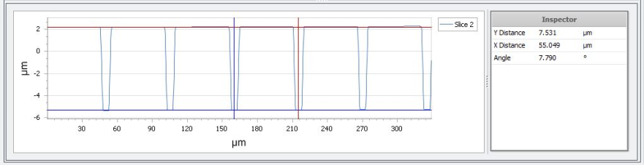

Height=7.531 μm Pitch=55.049 μm

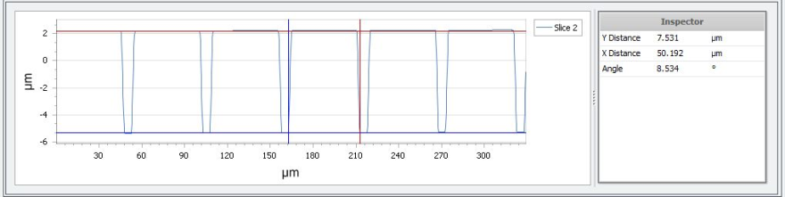

Height=7.531 μm Diameter=50.192 μm

**Developed, Fabricated and Measured Cylindrical Microcapsule Arrays for Nanoparticles Encapsulation**

|  |  |
| --- | --- |
| **Main Parameters of Developed, Fabricated**  **and Measured Cylindrical Microcapsule Array** | |
| Diameter of Cylindrical Microcapsule, µm | ⁓ 50 |
| Height of Microcapsules, µm | ⁓ 7.5 |
| Pitch of Microcapsules in Array, µm | 55 × 55 |
| Dimensions of Nanoparticles Encapsulated in Microcapsules, nm | 200 - 250 |
| Number of Microcapsules in Array | 400 × 400 |
| Size of Microcapsule Array, mm | 22 × 22 |
| Roughness of Microcapsules, nm | ˂ 0.5 |

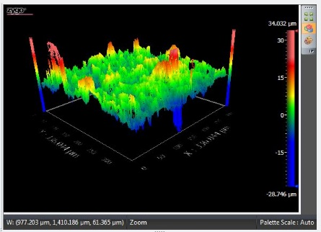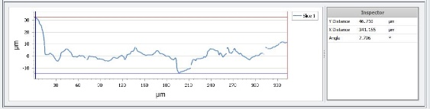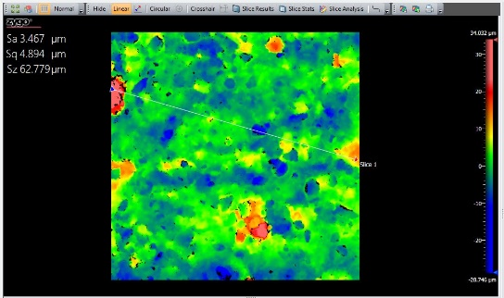

**500µm**

**2D Measurement**

**2D and 3D Measurement Results of Micro- structure of Fat Bloom Formed on Aroma Espresso Bar Chocolate Surface.**

Roughness: Maximum Peak-to-Valley Profile Height, Sz = 62.779 µm.

**3D Measurement**

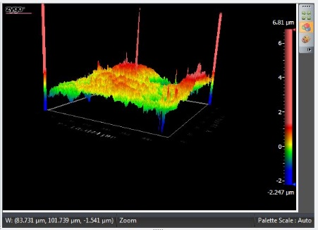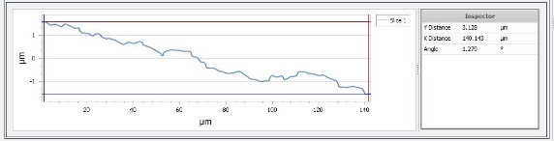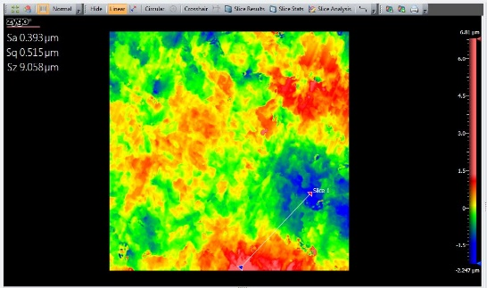

**500µm**

**2D Measurement**

**2D and 3D Measurement Results of Micro- structure of Aroma Espresso Bar Chocolate without Fat Bloom on Surface.**

Roughness: Maximum Peak-to-Valley Profile Height, Sz = 9.058 µm.

**3D Measurement**

**Our Experience in Fast Non-Destructive 3D&2D High Resolution Measurements of Food Nano/Micro/Macro Structures**

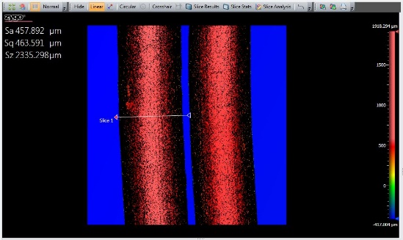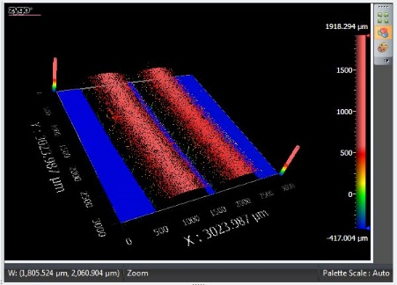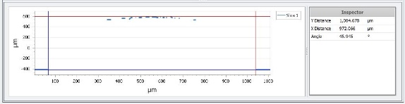

**500µm**

**2D and 3D Measurement Results of Micro- structures of Super Quality Wheat Vermicelli.**

1. Super Quality Wheat Vermicelli Sizes Along Axis X – 972.066 µm, Along Axis Y – 1,004.678 µm.

2. Roughness: Maximum Peak-to-Valley Profile Height, Sz = 2,335.298 µm.

**2D Measurement**

**3D Measurement**

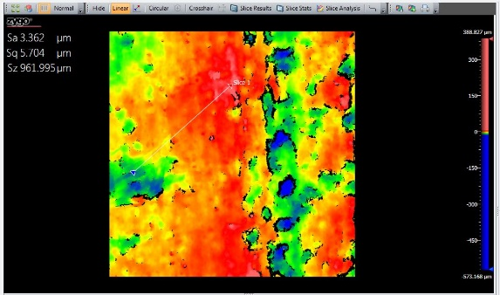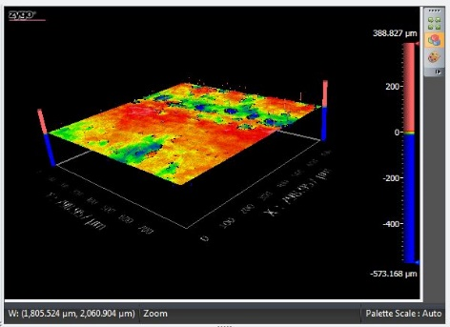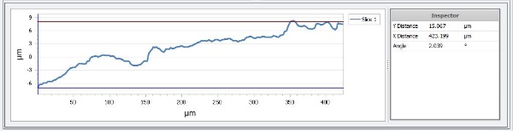

**500µm**

**2D Measurement**

**2D and 3D Measurement Results of Micro- structure of Sliced Emek Cheese.**

1. Roughness: Arithmetical Mean Height of a Surface, Sa = 3.362 µm.

2. Roughness: Maximum Peak-to-Valley Profile Height, Sz = 961.995 µm (Cheese Pore Depth).

**3D Measurement**

**Main Parameters of Dynamic Ultrafast Electro-Optical Beam Shaper with Peak on Flat Surface Beam Intensity Profile:** 1 - Simulation Result - Full Width at Half Maximum (FWHM) is 23 µm;

2 – Result of the Electro-optical Measurement of the developed and fabricated Dynamic Beam Shaper Sample: FWHM = 26 µm; Results of the Electro-optical Measurement of the Switching Time “On” is 375 µseconds, Switching Time “Off” is 450 µseconds.

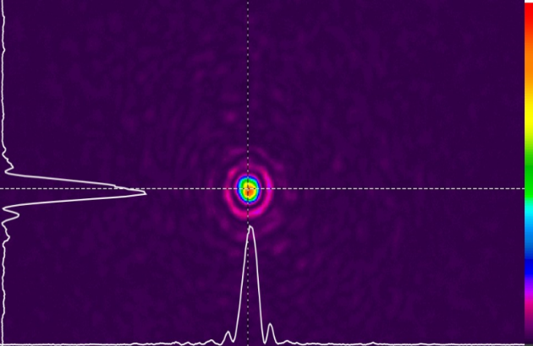

FWHM=26 µm



FWHM=23µm

**Dynamic Ultrafast Electro-Optical Beam Shapers were Simulated, Developed, Fabricated and Measured, which made it possible to obtained the following Versions of the Beam Intensity**

**Profiles: 1. Peak on Flat Surface; 2. M-shape; 3. Top-Hat Shape; 4. Peak on Pedestal.**