
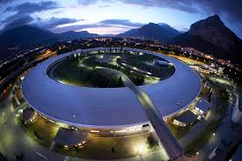
The Extended Relativity Research Center
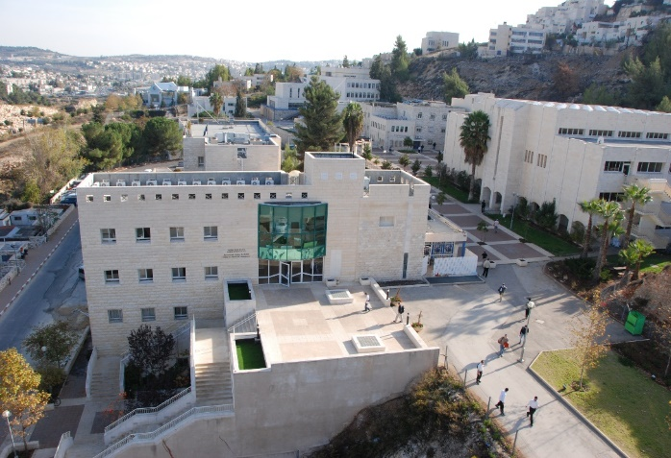
Proposal

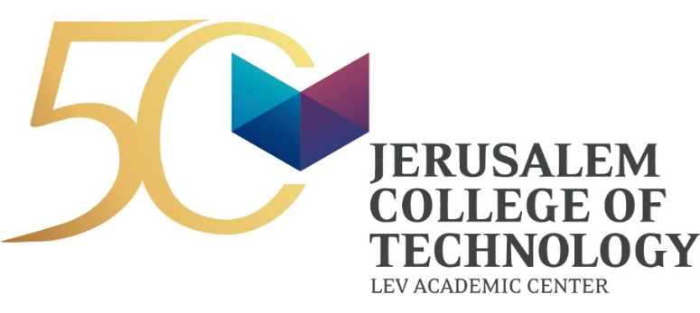

About JCT

Founded in 1969, the Jerusalem College of Technology (JCT) is one of Israel’s major academic institutions with about 4,800 students on three campuses. The College specializes in high-tech engineering, industrial management, business administration and health sciences and is fully accredited by Israel’s Council of Higher Education. JCT’s two-fold mission is to train highly skilled professionals for Israel’s rapidly growing hi-tech industries while also instilling within them a strong commitment to Jewish values and ethics, the Jewish people, and the State of Israel. Dedicated to strengthening Jerusalem and addressing Israel’s socio-economic needs, JCT empowers diverse segments of Israeli society who would otherwise not be able to pursue higher education- such as Ethiopians and Ultra-Orthodox men and women- to become productive members of Israel’s competitive workforce.

For almost 50 years, JCT’s advanced academic leadership, high ethical and professional standards, innovative programming and distinctive emphasis on practical applied skills, have earned the College international recognition for excellence. Advanced research and development at JCT has led to major advances in fields ranging from cyber security to medical technology and driving safety. JCT alumni and faculty have spearheaded projects critically important to Israel's national security and have received prestigious awards from the IDF Chief of Staff and the Ministry of Defense.

The Extended Relativity Research Center

Originally formulated by Einstein in the early 1900’s, the theory of relativity transformed theoretical physics and astronomy during the 20th century. To date, the microscopic region is still described by quantum mechanics. It was Einstein’s ultimate dream to find a way to extend the theory of relativity to include the microscopic regime through a theory that has been coined, “The Theory of Everything”. Despite intensive efforts by scientists, mathematicians and researchers worldwide to realize this vision, no one has yet been able to find a consistent theory of extended relativity that can be appliedto new domains. The process requires building an entirely new mathematical model that can be applied both to quantum mechanics as well as general relativity. This ambitious task can only be achieved by someone who possesses the broad and in-depth knowledge and proficiency necessary in both fields.

Over the last two decades, JCT Professor Yaakov Friedman, a leading researcher with expertise in mathematics, physics and high precision experiments has been at the forefront of revolutionary research dedicated to extending the theory of relativity - the fulfillment of Einstein’s dream. Based on his groundbreaking research and unique capabilities in the aforementioned fields, Friedman has prepared the mathematical and

scientific foundation required to build the model that will be able to achieve the “unification of physics” by uniting general relativity with quantum mechanics. The theory, when completed and proven, will significantly impact technological development, bringing it from the nanoscale into the quantum region. Among many areas of potential impact, the theory will ultimately enable the production of smaller, faster and higher precision technological devices.

Spanning 20 years, the first stage of Friedman’s research was dedicated to identifying the components of the theory that needed clarification and modification. To date, the project has produced 35 published scientific essays. Friedman has prepared a solid foundation to support the “Extended Theory of Relativity” that includes scientific evidence in specific areas and has most recently reached a much anticipated new stage of development.

The Need

Progression of the theory to a more advanced stage of development requires extensive testing and research. Due to the complex nature of this ambitious research, at this stage the project requires the assistance of additional team members to carry out the full scope of work necessary. The new model will have to be able to prove the unification of theoretical physics through astronomical observations, tests and experiments using satellites and particle accelerators.

While Friedman previously worked independently on the project with the assistance of several committed JCT students, the next stage of development requires expanding the team to include other professional researchers, physicists and PhD students. This intermediate stage will require comprehensive research, writing, and case studies to further test these mathematical models, prove their legitimacy and gain wide-scale international recognition. Once the theory accumulates sufficient scientific evidence, (approx. two years of extensive research), we expect the project will then move on to receive full recognition and support from the Israeli government as well as international research associations.

Funding needs for the intermediate stage of development over two years include:

- Minimum of two PhD-levelresearchers
- Hosting four to five visiting professors to participate in collaborative research
- Hosting lectures and seminars that will be open to the larger community
- Participating in international conferences
- Research expenses (equipment)
- PR, marketing and publicity

Project Goals
- Extend Einstein’s theory of relativity to understand and describe microscopic behavior (the fulfillment of Einstein’s dream)
- Educate the next generation of scientists in the theory of Extended Relativity
- Prove the validity of the theory through astronomical observations and experiments at the world’s most powerful accelerators
- Explore the implications of the theory in the microscopic regime
- Expose the ideas of Extended Relativity to the wider, international community
- Initiate projects that translate the theory into technological development

Projected Budget for two years (3.6 NIS = $1)
Expense | Details | Cost in US$
PhD student research grants | Two students, two years | 60,000
Professional researchers | One-first year, two-second year | 171,000
Hosting visiting professors | Four professors | 14,350
Hosting and attending international conferences | Expense includes travel abroad for two research team members | 17,300
Materials for research experiments |  | 8,650
PR, marketing and publicity |  | 5,800
Overhead |  | 23,100
Total Expenses |  | $300,200

Funding Request:
JCT is seeking $300,200 to fund this project at its critically important stage of development over the next two years. We are confident that this pioneering work will significantly impact international scientific and technological development.
We hope you will join us in supporting cutting-edge leadership, research and innovation in Israel.

